*Junit Basic Testing Exercises*

# *Exercise 1: SETTING UP JUNIT:*

***Scenario:***

***You need to set up JUnit in your Java project to start writing unit tests.***

## *SOLUTION:*

*Step 1. Create or Open a* ***Maven Project*** *:*

*You can use an IDE like* ***IntelliJ IDEA****,* ***Eclipse****, or set it up manually.*

*Step 2. Click File-> New-> Maven Project(Click on create a simple project) Then write the name of group id and artifact id and then click on finish button.*

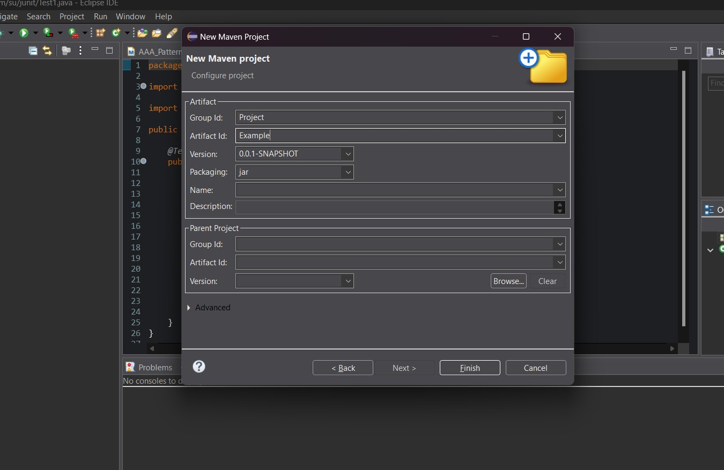

*Step 3. Add* ***Junit Dependency*** *to your project . Add following to your* ***pom.xml*** *file:*

***Pom.xml:****<project xmlns*[*="http://maven.apache.org/POM/4.0.0"*](http://maven.apache.org/POM/4.0.0) *xmlns:x*[*si="http://www.w3.org/2001/XMLSchema-instance"*](http://www.w3.org/2001/XMLSchema-instance)

*xsi:schemaLocati*[*on="http://maven.apache.org/POM/4.0.0*](http://maven.apache.org/POM/4.0.0) *https://maven.apache.org/xsd/maven- 4.0.0.xsd">*

*<modelVersion>4.0.0</modelVersion>*

*<groupId>Project</groupId>*

*<artifactId>Example</artifactId>*

*<version>0.0.1-SNAPSHOT</version>*

*<dependencies>*

*<!-- JUnit Jupiter (API + Engine) -->*

*<dependency>*

*<groupId>org.junit.jupiter</groupId>*

*<artifactId>junit-jupiter</artifactId>*

*<version>5.9.3</version>*

*<scope>test</scope>*

*</dependency>*

*</dependencies>*

*<build>*

*<plugins>*

*<!-- Correct Surefire Plugin version to support JUnit 5 -->*

*<plugin>*

*<groupId>org.apache.maven.plugins</groupId>*

*<artifactId>maven-surefire-plugin</artifactId>*

*<version>3.0.0-M9</version>*

*</plugin>*

*</plugins>*

*</build>*

*</project>*

*Then run this by maven test.*

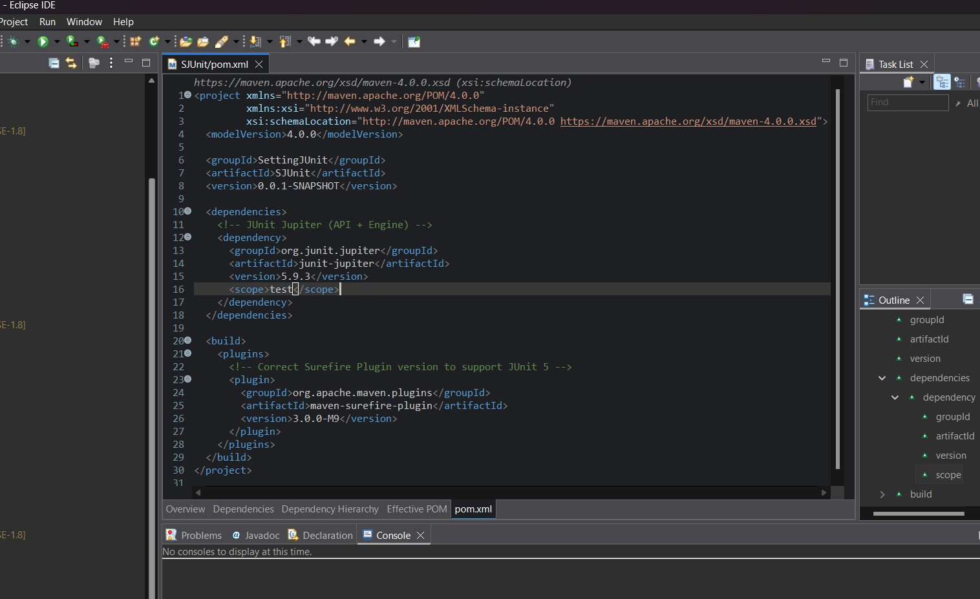

*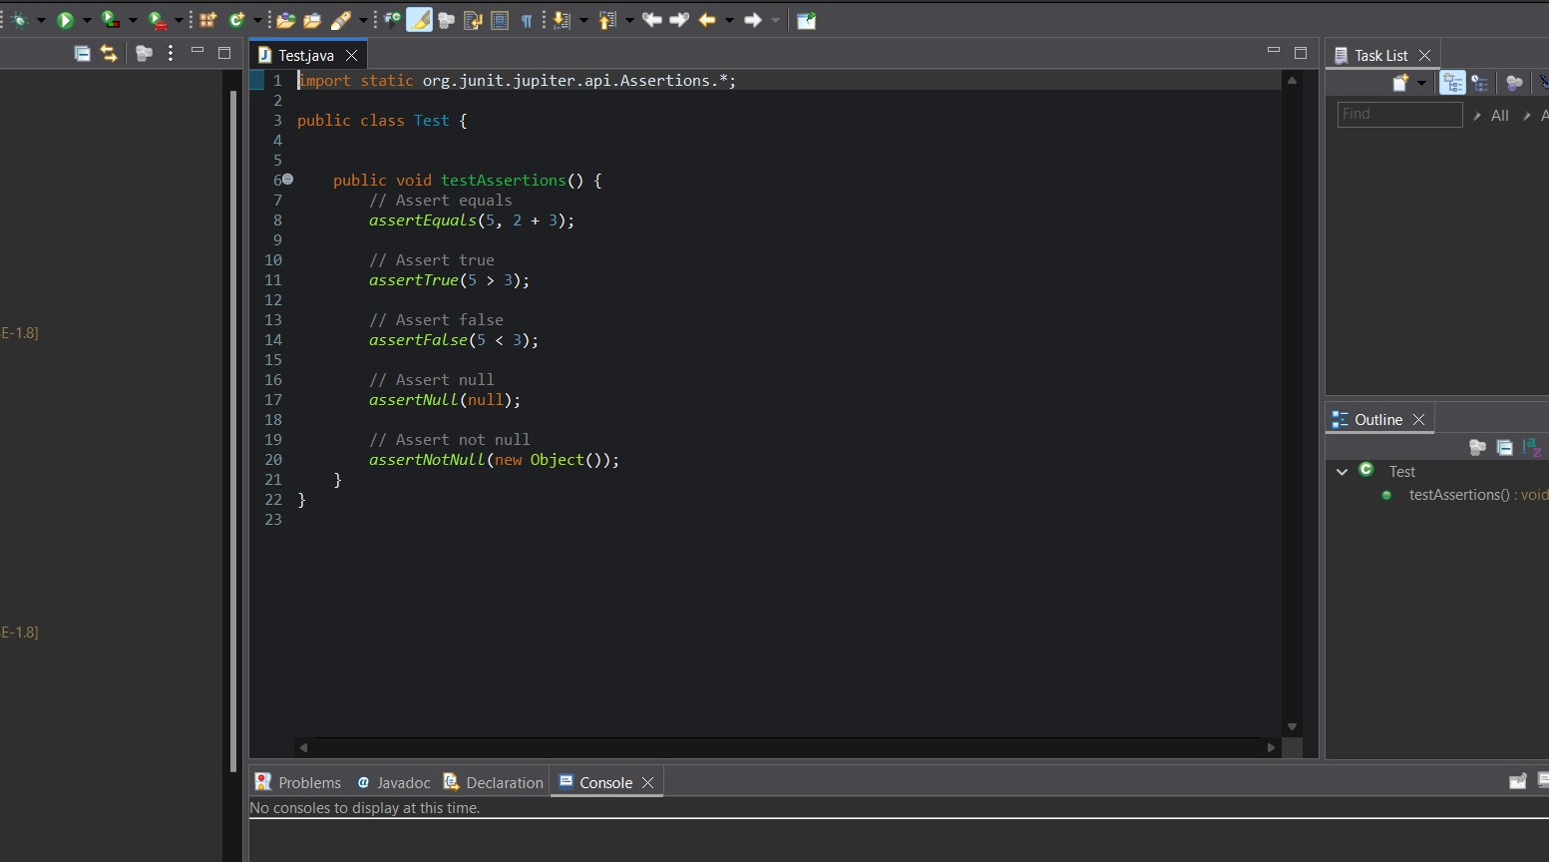Step 4. Create your test classes in* ***src/test/java****. Write a sample test case:*

## *CODE:*

*import static org.junit.jupiter.api.Assertions.*; public class Test {*

*public void testAssertions() {*

*assertEquals(5, 2 + 3);*

*assertTrue(5 > 3);*

*assertFalse(5 < 3);*

*assertNull(null);*

*assertNotNull(new Object());*

*}*

*}*

*Step 5. Then run the test class in* ***maven test*** *and then* ***Junit test*** *.*

## *OUTPUT:*

***Maven Test:***

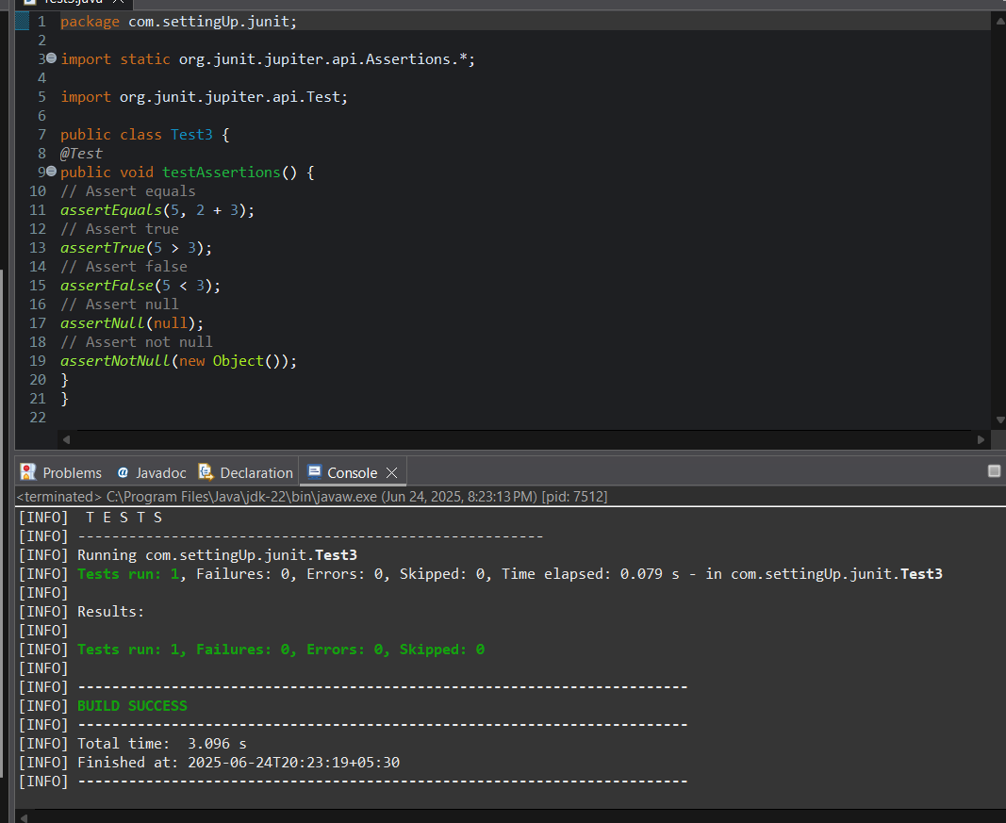

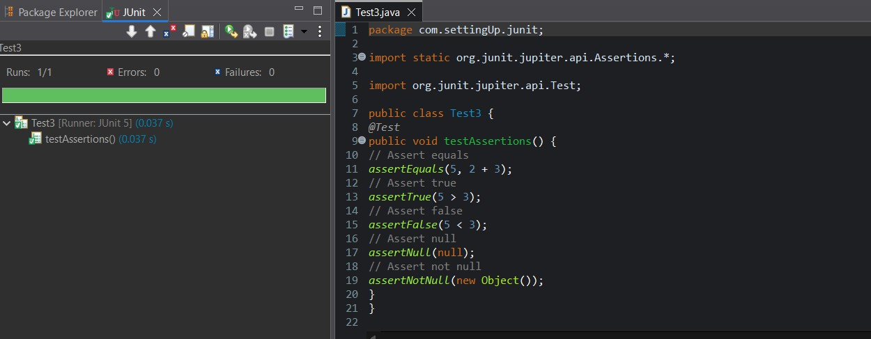***Junit Test:***

# *Exercise 3: Assertions in Junit*

***Scenario:***

***You need to use different assertions in JUnit to validate your test results***

## *SOLUTION:*

*Step 1:Add the Junit Dependency in pom.xml*

### *pom.xml :*

*<project xmln*[*s="http://maven.apache.org/POM/4.0.0"*](http://maven.apache.org/POM/4.0.0) *xmlns:x*[*si="http://www.w3.org/2001/XMLSchema-instance"*](http://www.w3.org/2001/XMLSchema-instance)

*xsi:schemaLocati*[*on="http://maven.apache.org/POM/4.0.0*](http://maven.apache.org/POM/4.0.0) *https://maven.apache.org/xsd/maven- 4.0.0.xsd">*

*<modelVersion>4.0.0</modelVersion>*

*<groupId>sudeep</groupId>*

*<artifactId>AssertionInJUnit</artifactId>*

*<version>0.0.1-SNAPSHOT</version>*

*<dependencies>*

*<!-- JUnit Jupiter (API + Engine) -->*

*<dependency>*

*<groupId>org.junit.jupiter</groupId>*

*<artifactId>junit-jupiter</artifactId>*

*<version>5.9.3</version>*

*<scope>test</scope>*

*</dependency>*

*</dependencies>*

*<build>*

*<plugins>*

*<!-- Correct Surefire Plugin version to support JUnit 5 -->*

*<plugin>*

*<groupId>org.apache.maven.plugins</groupId>*

*<artifactId>maven-surefire-plugin</artifactId>*

*<version>3.0.0-M9</version>*

*</plugin>*

*</plugins>*

*</build>*

*</project>*

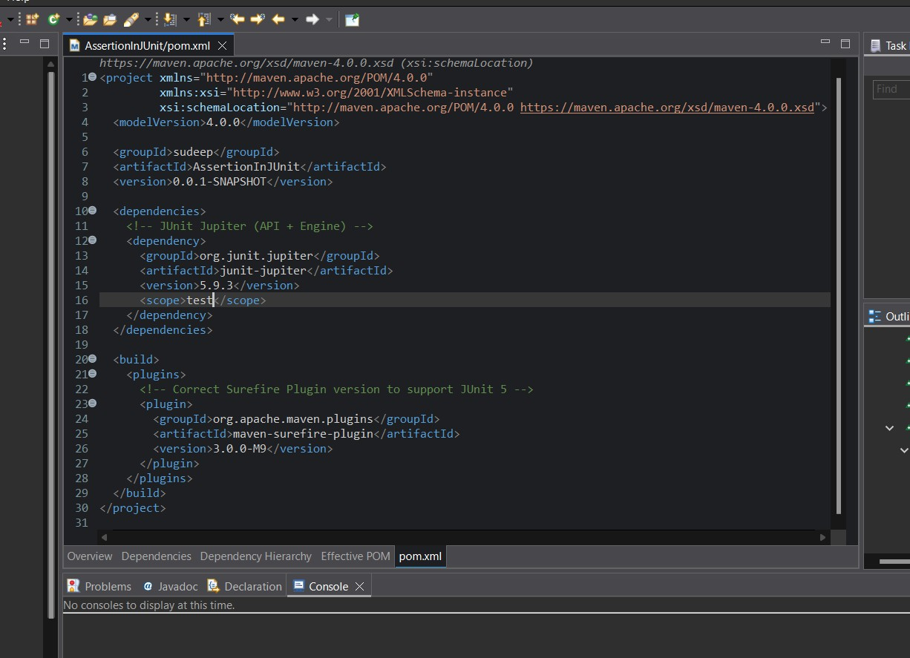

*Step 2: Create your test classes in* ***src/test/java****.*

*Write the required test case and run as maven test and Junit test:*

***CODE:***

*package com.AssertionInJUnit.junit; import org.junit.jupiter.api.Test;*

*import static org.junit.jupiter.api.Assertions.*; public class Assertion {*

*@Test*

*public void testAssertions() {*

*// Assert equals*

*assertEquals(5, 2 + 3);*

*// Assert true*

*assertTrue(5 > 3);*

*// Assert false*

*assertFalse(5 < 3);*

*// Assert null*

*assertNull(null);*

*// Assert not null*

*assertNotNull(new Object());*

*}*

*}*

## *OUTPUT:*

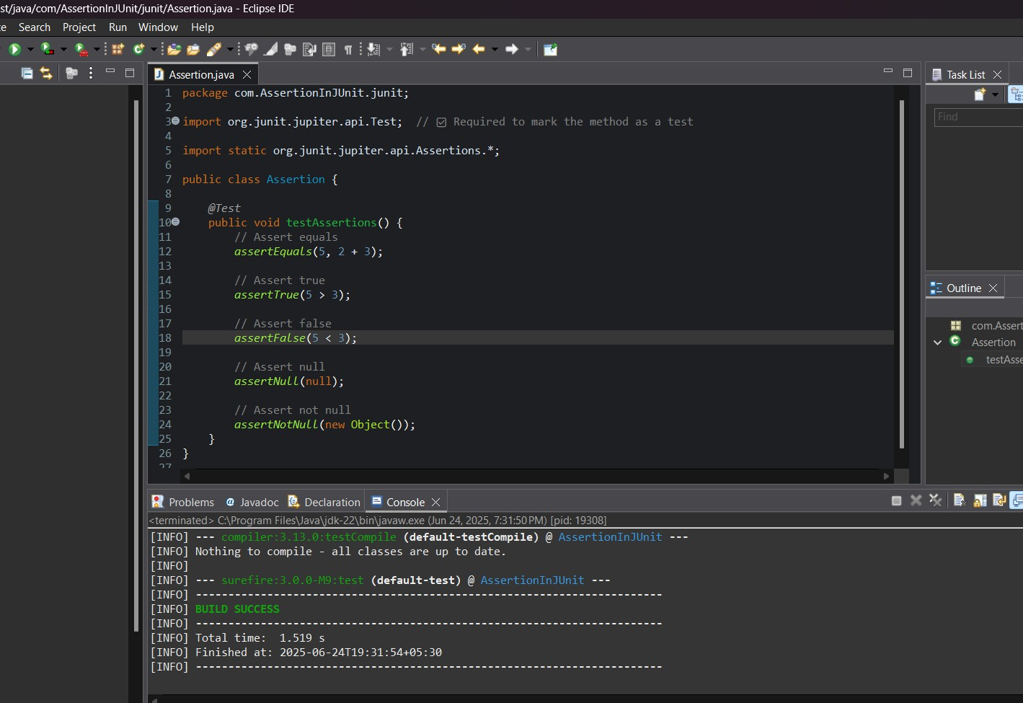***Maven test:***

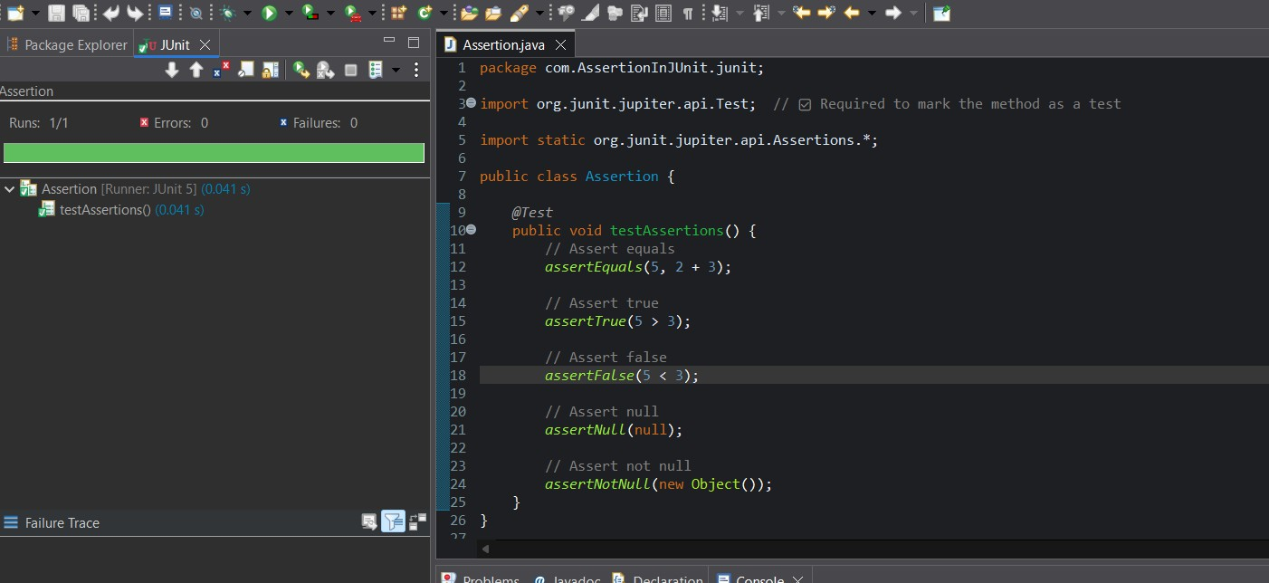***Junit test:***

# *Exercise 4: Arrange-Act-Assert (AAA) Pattern, Test Fixtures, Setup and Teardown Methods in Junit*

***Scenario:***

***You need to organize your tests using the Arrange-Act-Assert (AAA) pattern and use setup and teardown methods.***

## *SOLUTION:*

*Step 1:Add the Junit Dependency in pom.xml*

### *pom.xml :*

*<project xmln*[*s="http://maven.apache.org/POM/4.0.0"*](http://maven.apache.org/POM/4.0.0) *xmlns:x*[*si="http://www.w3.org/2001/XMLSchema-instance"*](http://www.w3.org/2001/XMLSchema-instance)

*xsi:schemaLocati*[*on="http://maven.apache.org/POM/4.0.0*](http://maven.apache.org/POM/4.0.0) *https://maven.apache.org/xsd/maven- 4.0.0.xsd">*

*<modelVersion>4.0.0</modelVersion>*

*<groupId>AAA</groupId>*

*<artifactId>AAA_Pattern</artifactId>*

*<version>0.0.1-SNAPSHOT</version>*

*<dependencies>*

*<!-- JUnit Jupiter (API + Engine) -->*

*<dependency>*

*<groupId>org.junit.jupiter</groupId>*

*<artifactId>junit-jupiter</artifactId>*

*<version>5.9.3</version>*

*<scope>test</scope>*

*</dependency>*

*</dependencies>*

*<build>*

*<plugins>*

*<!-- Correct Surefire Plugin version to support JUnit 5 -->*

*<plugin>*

*<groupId>org.apache.maven.plugins</groupId>*

*<artifactId>maven-surefire-plugin</artifactId>*

*<version>3.0.0-M9</version>*

*</plugin>*

*</plugins>*

*</build>*

*</project>*

### *OUTPUT:*

*Step 2: Create your test classes in* ***src/test/java****.*

*Write the required test case and run as maven test and Junit test:*

***CODE for Calculator.java:*** *package com.AAA.patterns; public class Calculator {*

*public int add(int a, int b) { return a + b;*

*}*

*public int subtract(int a, int b) { return a - b;*

*}*

*}*

***OUTPUT:***

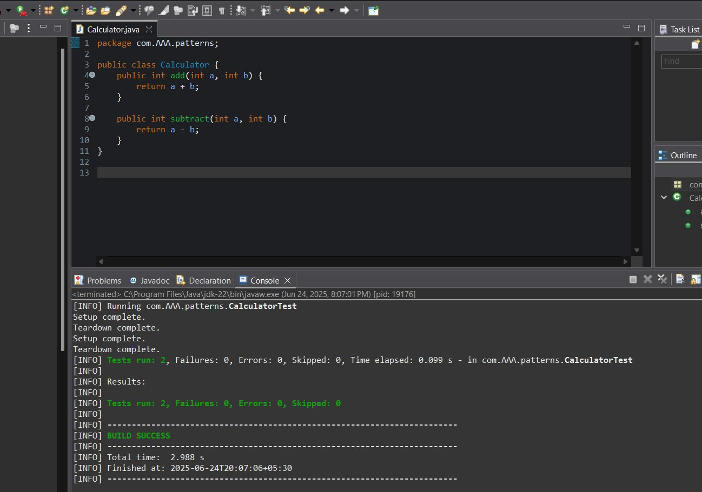***Maven Test for Calculator.java:***

***CODE for CalculatorTest.java:***

*package com.AAA.patterns; import org.junit.jupiter.api.*;*

*import static org.junit.jupiter.api.Assertions.*; public class CalculatorTest {*

*private Calculator calculator;*

*@BeforeEach*

*void setUp() {*

*calculator = new Calculator(); System.out.println("Setup complete.");*

*}*

*@AfterEach*

*void tearDown() { calculator = null;*

*System.out.println("Teardown complete.");*

*}*

*@Test*

*void testAddition() {*

*// Arrange int a = 10; int b = 5;*

*// Act*

*int result = calculator.add(a, b);*

*// Assert*

*assertEquals(15, result);*

*}*

*@Test*

*void testSubtraction() {*

*// Arrange int a = 10; int b = 3;*

*// Act*

*int result = calculator.subtract(a, b);*

*// Assert*

*assertEquals(7, result);*

*}*

*}*

## *OUTPUT:*

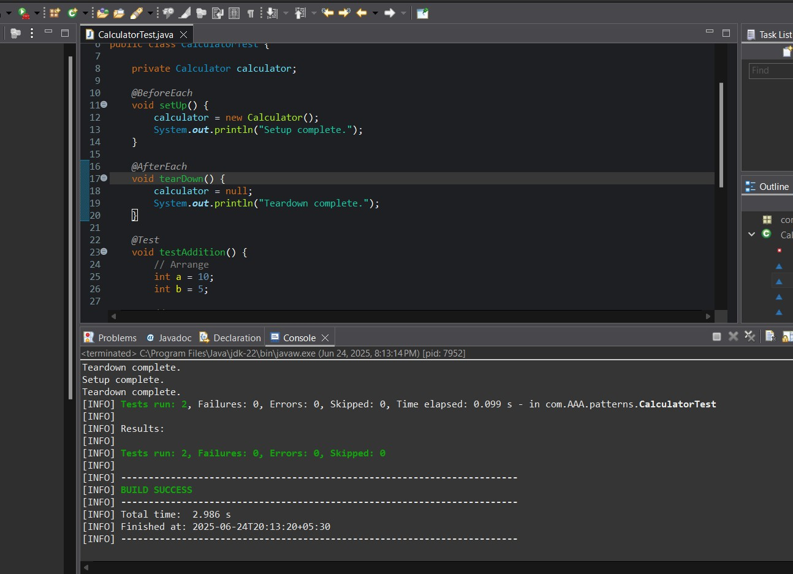***Maven Test for CalculatorTest.java:***

***Junit Test for CalculatorTest.java:***

